**QUESTION:**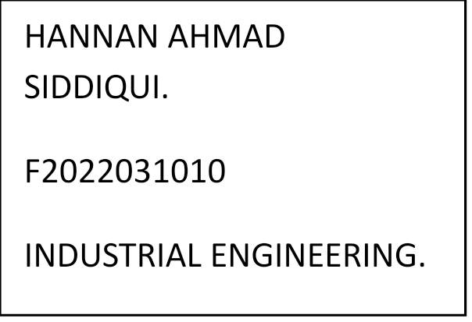

**AI and machine learning, Big data influence in the field of engineering.**

**ANSWER:**

**Big Data?**

* **With big data solutions, organizations generate insights and make well-informed decisions, improve productivity and discover trends. Big data provides many opportunities for organizations and makes an impact on businesses, the workforce, and society.**

**Big data can influence in the field of engineering with some following examples.**

* **In industrial Engineering Big Data can help us to focus in on product defects and inconsistencies in manufacturing.**
* **In Software Engineering Big Data can help in finding the best practices for refining your software development life cycle.**
* **In Civil Engineering Big Data** **can help** **transforming the sector, creating new opportunities, from saving time to increasing efficiency and improving environmental performance**.